Hymera Fire Department
Car Show
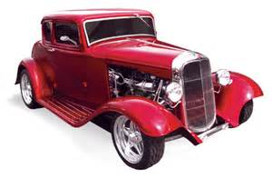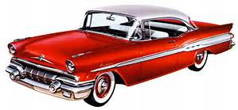

Saturday August 26, 2023
Hymera Masonic Lodge Northside Lot– 201 N State St Hymera, Indiana
Time: 10:00 a.m. to 3:00 p.m.
Registration to 1:00 p.m.
Entry Fee: $10.00
Door prizes
Dash plaques for first 40 cars
Awards: Best of Show, and Top 5

